FOR IMMEDIATE RELEASE. Duo of Scholars Release Critical Issues in Education Text

Clarkston, GA – Georgia State University Perimeter College

Newark, OH – Ohio State University Newark

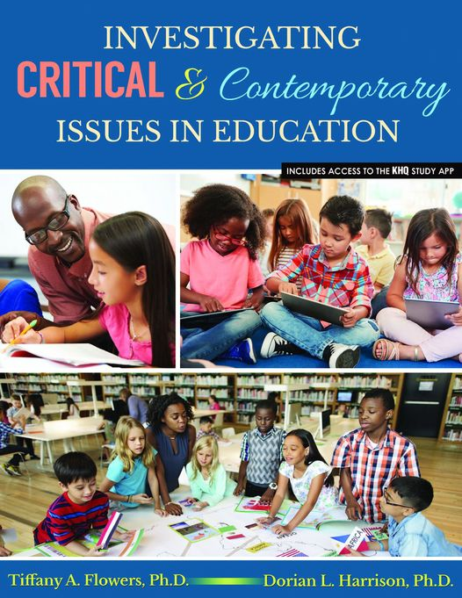
Kendall-Hunt
ISBN# 978-1-7924-8573-2

Investigating Critical & Contemporary Issues in Education by Dr. Tiffany A. Flowers and Dr. Dorian Harrison is a foundational text for undergraduate education majors. The text focuses on the historical and theoretical underpinnings in the field. Additionally, the text features include 21st century topics from civil rights in education, reform, international education, and social and political issues in education.

“Our purpose behind writing this text was to create a reflective work for undergraduates to understand critical ongoing issues in the field. We hope that higher education professionals who use this text in their courses for preservice teachers find our work salient and meaningful for their students.”

Dr. Tiffany A. Flowers is an associate professor of education at Georgia State University Perimeter College in the department of cultural and behavioral sciences. She is a native Chicagoan and a graduate of Virginia Commonwealth University where she earned a B.S. in psychology and a M.A.T. in early childhood education. Tiffany also earned an M.A. in social and philosophical foundations of education and a Ph.D. in language, literacy, and culture from the University of Iowa. Dr. Flowers is a member of the Diversity Scholars Network at the University of Michigan. She is a West Chester University Frederick Douglas Teaching Fellow and an Indiana University Minority Faculty Fellow. Dr. Flowers is also a 2014 NCTE Early Career Educator of Color award recipient.

Dr. Dorian Harrison is an assistant professor in the College of Education and Human Ecology’s Department of Teaching and Learning at The Ohio State University at Newark. She teaches foundational and licensure course in literacy at the undergraduate and graduate level. Dr. Harrison has over 15 years of experience in education. She worked as an elementary teacher, Pre-K teacher, literacy specialist, educational consultant, after school program director, and college coach/tutor. Dr. Dorian Harrison is a member of the Diversity Scholars Network at the University of Michigan. Dr. Harrison is also a 2021 NCTE Early Career Educator of Color award recipient.

Contact: Dr. Tiffany A. Flowers, tflowers@gsu.eduand Dr. Dorian Harrison, harrison.898@osu.edu

